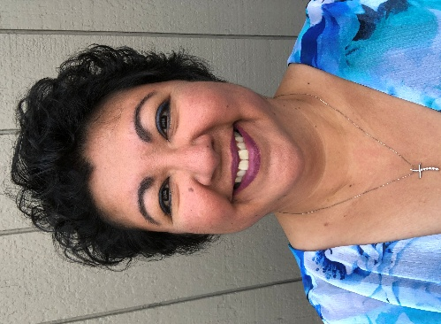

(Two samples of Bio photos)

Sample Bio based on my answers to Example Questions from Hubspot:

Name and background: Always start your professional bio by introducing yourself and providing some context about who you are and your experience.
Roberta “Kitigruak” Richardson lives in Anchorage, Alaska with her husband who is her best friend and their spoiled-rotten dog and cat. She is of Inupiaq descent and grew up in both rural and urban areas of Alaska. Born into a family who loves Jesus, her late-grandfather was a beloved pastor and superintendent of Friend’s Church and her late-grandmother faithfully supported his calling in various cities and villages of Alaska. Roberta’s great-grandmother worked to translate the Bible into pictograph images to help people understand the Word in the late 1800 to early 1900’s in Northwest Alaska.

Professional roles and achievements: Highlight your previous roles, what you currently do for work, and an accomplishment or two. You know, brag a little.
Roberta currently serves LIM as the Lead Ministry Coordinator and joined LIM in July 2023. Prior to joining LIM, Roberta’s career included the privilege of working in family wellness programs and prior to that a long career in Human Resources with her SPHR, GPHR, and SHRM-SCP designations. Roberta credits her earthly work experiences that were led by God to bring her to serving in ministry, a role she never imagined she would be in - and she is grateful for God’s calling in her life.
Values and work approach: What do you care about? What drives the way you think about work? Include that here.
Roberta loves Jesus and the joy of the Lord is her strength – she loves to laugh! And seeing the Holy Spirit free people from the enemy’s bondage of lies and generational harm either done to them or done by them through learning Biblical truth fills her cup over and over again. Roberta values others wherever they are at and she loves meeting new people and making new friends. Roberta knows through God all things are possible and that Jesus is the way, the truth and the life and that he is the only way to the Father. She knows that Jesus paid our debt and saved each and every one of us, and all we have to do is believe in Him – she is in constant awe of Jesus!
Passions and interests: Yes, you should absolutely save room to share your hobbies and talk a little bit about your personal life. This really helps the reader understand who you are beyond your professional achievements.
Roberta loves family time and taking care of her pets. Roberta loves to learn, read, travel, see new places and try new foods with her husband. Her most favorite thing of all is laughter! Laughter with family, friends, her pets and anyone who will share a laugh with her! She loves sharing the joy of the Lord!
Call-to-action: Tell the reader what to do next. Now that they’ve met you in writing, what’s the ideal path forward for you (and for them)?
Roberta is excited to see what else God has in store for this ministry! She feels incredibly blessed to work with a dynamic team who love the Lord and love supporting one another in spreading the Gospel. The LIM Board loves the Lord! LIM leadership loves to serve and spread the Word in our mission and vision, and it shows in our values and how we labor for God’s glory! Join us in a healing group and experience this for yourself, we hope to see you soon! May the Lord Jesus bless you and keep you!
Source of Questions: https://blog.hubspot.com/marketing/professional-bio-examples

Sample Final Draft: Note – this will still need editing for length and conciseness!
Roberta “Kitigruak” Richardson lives in Anchorage, Alaska with her husband who is her best friend and their spoiled-rotten dog and cat. She is of Inupiaq descent and grew up in both rural and urban areas of Alaska. Born into a family who loves Jesus, her late-grandfather was a beloved pastor and superintendent of Friend’s Church and her late-grandmother faithfully supported his calling in various cities and villages of Alaska. Roberta’s great-grandmother worked to translate the Bible into pictograph images to help people understand the Word in the late 1800 to early 1900’s in Northwest Alaska.
Roberta currently serves LIM as the Lead Ministry Coordinator and joined LIM in July 2023. Prior to joining LIM, Roberta’s career included the privilege of working in family wellness programs and prior to that a long career in Human Resources with her SPHR, GPHR, and SHRM-SCP designations. Roberta credits her earthly work experiences that were led by God to bring her to serving in ministry, a role she never imagined she would be in - and she is grateful for God’s calling in her life.
Roberta loves Jesus and the joy of the Lord is her strength – she loves to laugh! And seeing the Holy Spirit free people from the enemy’s bondage of lies and generational harm either done to them or done by them through learning Biblical truth fills her cup over and over again. Roberta values others wherever they are at and she loves meeting new people and making new friends. Roberta knows through God all things are possible and that Jesus is the way, the truth and the life and that he is the only way to the Father. She knows that Jesus paid our debt and saved each and every one of us, and all we have to do is believe in Him – she is in constant awe of Jesus!
Roberta loves family time and taking care of her pets. Roberta loves to learn, read, travel, see new places and try new foods with her husband. Her most favorite thing of all is laughter! Laughter with family, friends, her pets and anyone who will share a laugh with her! She loves sharing the joy of the Lord!
Roberta is excited to see what else God has in store for this ministry! She feels incredibly blessed to work with a dynamic team who love the Lord and love supporting one another in spreading the Gospel. The LIM Board loves the Lord! LIM leadership loves to serve and spread the Word in our mission and vision, and it shows in our values and how we labor for God’s glory! Join us in a healing group and experience this for yourself, we hope to see you soon! May the Lord Jesus bless you and keep you!

